# MODULE 05 Defeating Anti-forensics Techniques

Lara Alofi

2110886

Y

Computer Hacking Forensic Investigator (CHFI)

Lab Session Identifiers

1. <https://labclient.labondemand.com/LabClient/e2e7e880-2440-40e3-b9ad-bbe98de96d56?showWhenStarting=1>
2. <https://labclient.labondemand.com/LabClient/c4bb1742-5048-4dbb-b85c-68b86a18a95b?showWhenStarting=1>

Username on EC-Council System

1. 2110886@uj.edu.sa

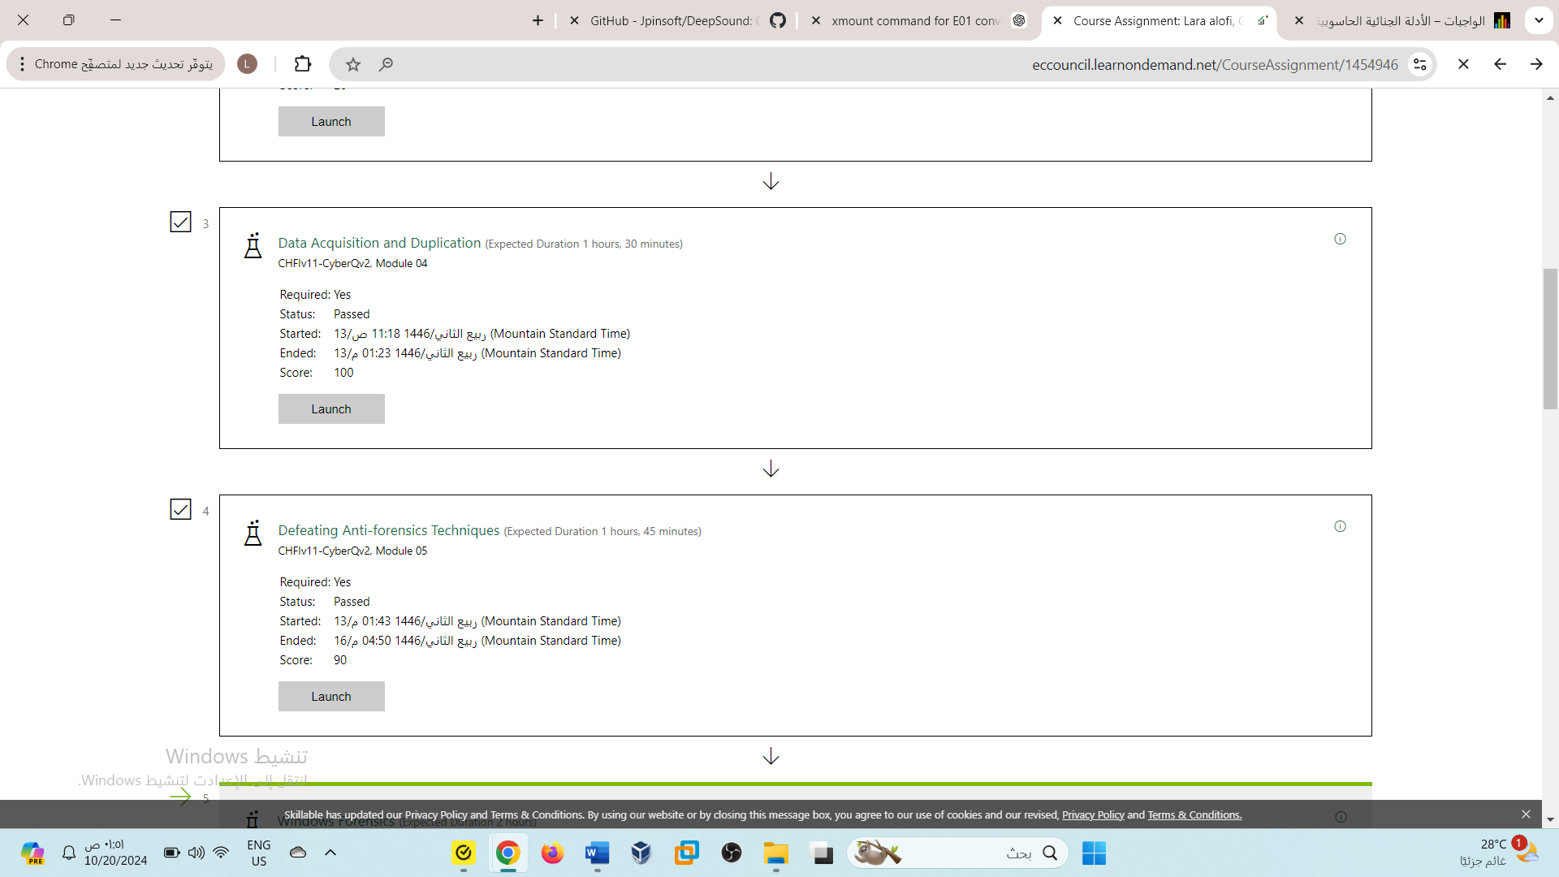

Lab 01

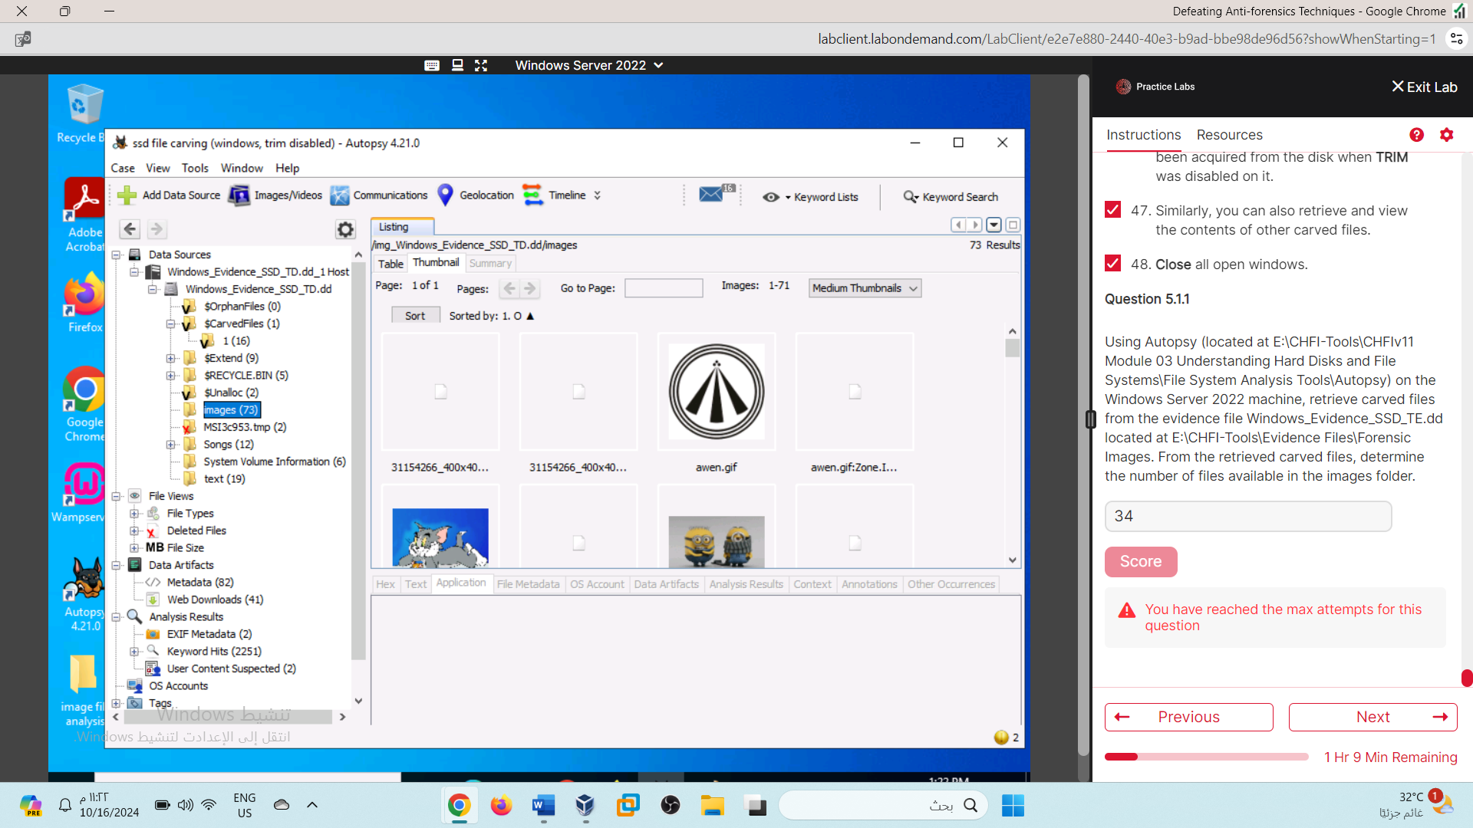

In a new session, I re-took Lab1 and submitted the correct answer

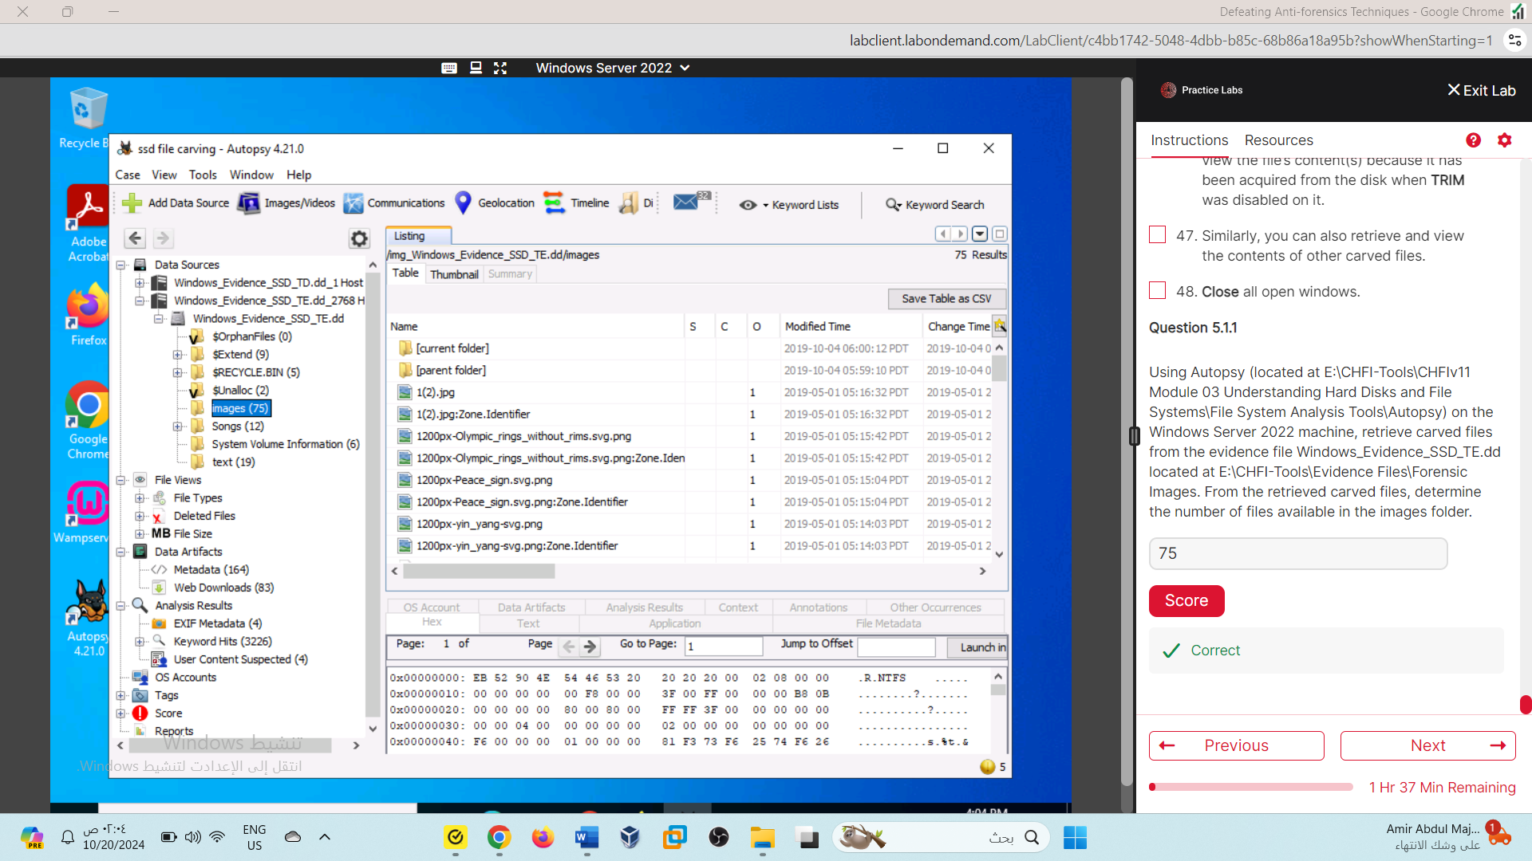

75

Lab 02

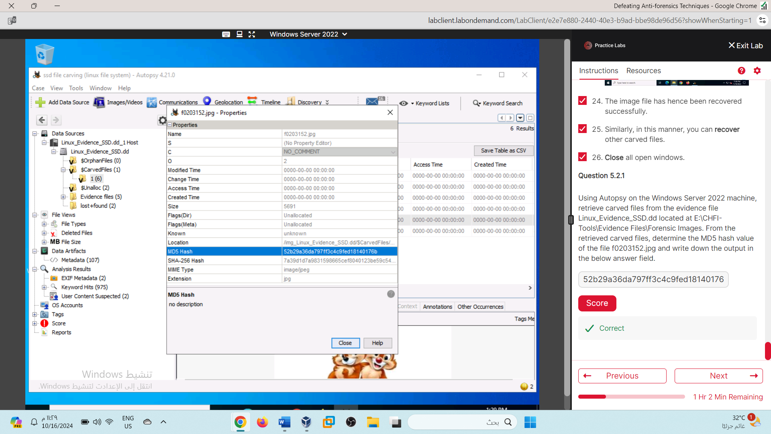

52b29a36da797ff3c4c9fed18140176b

Lab 03

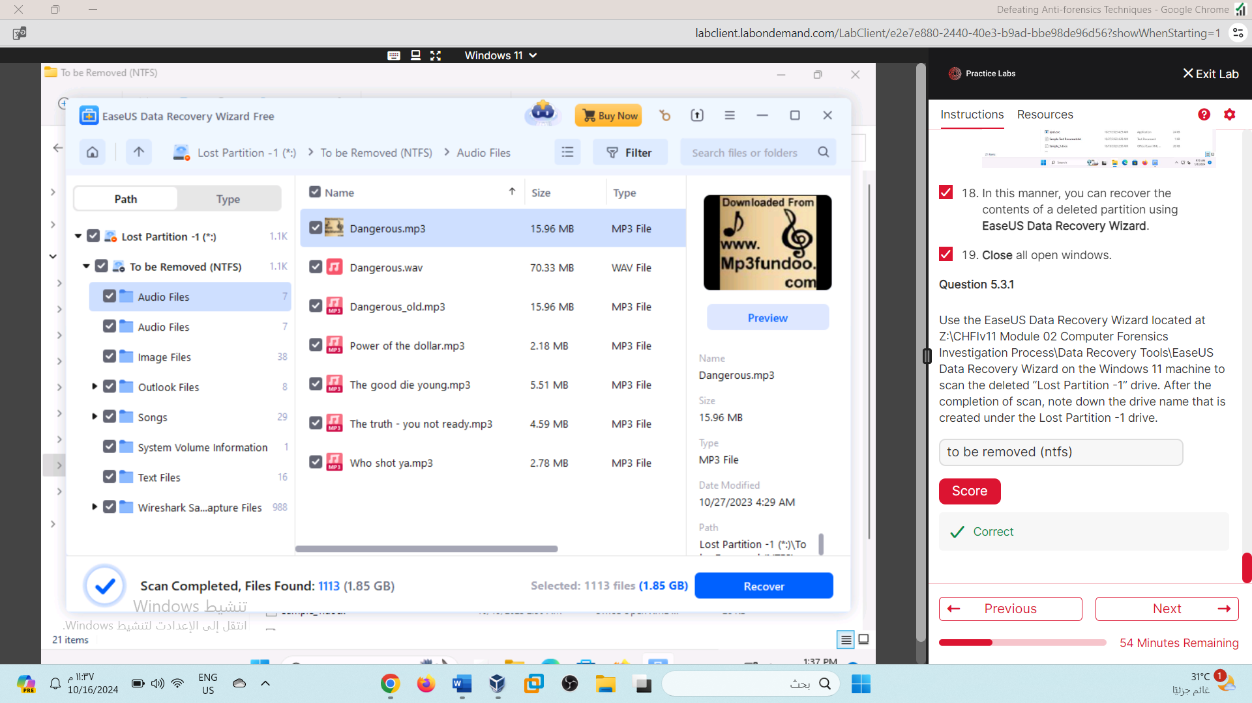

to be removed (ntfs)

Lab 04

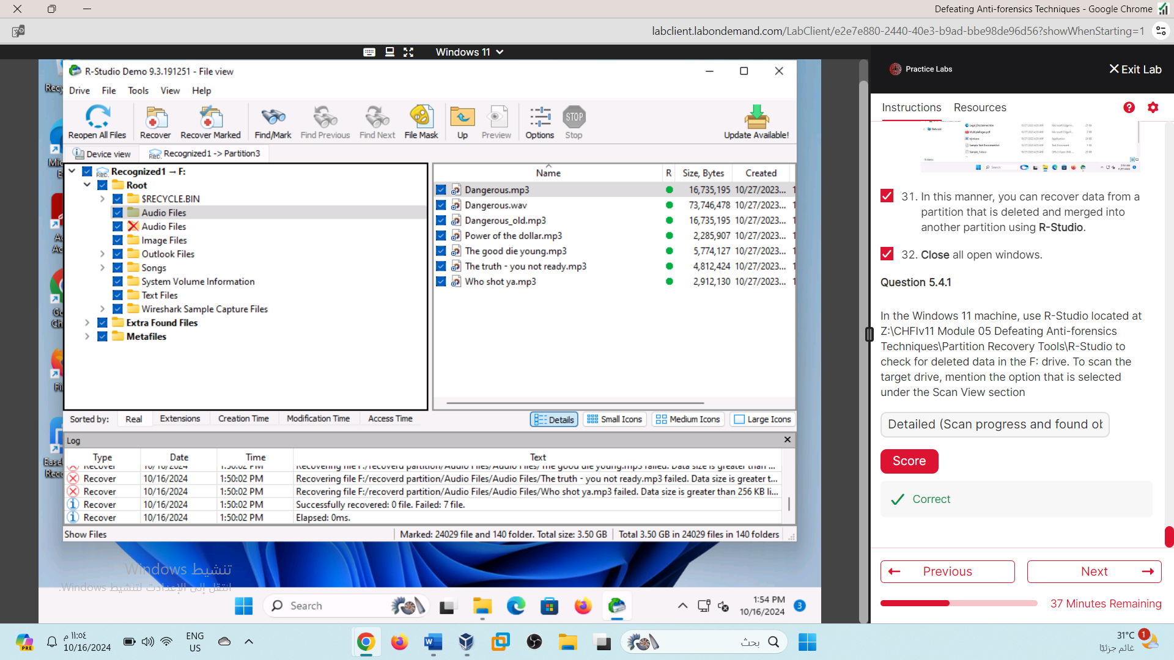

Detailed (Scan progress and found objects. Slower.)

Lab 05

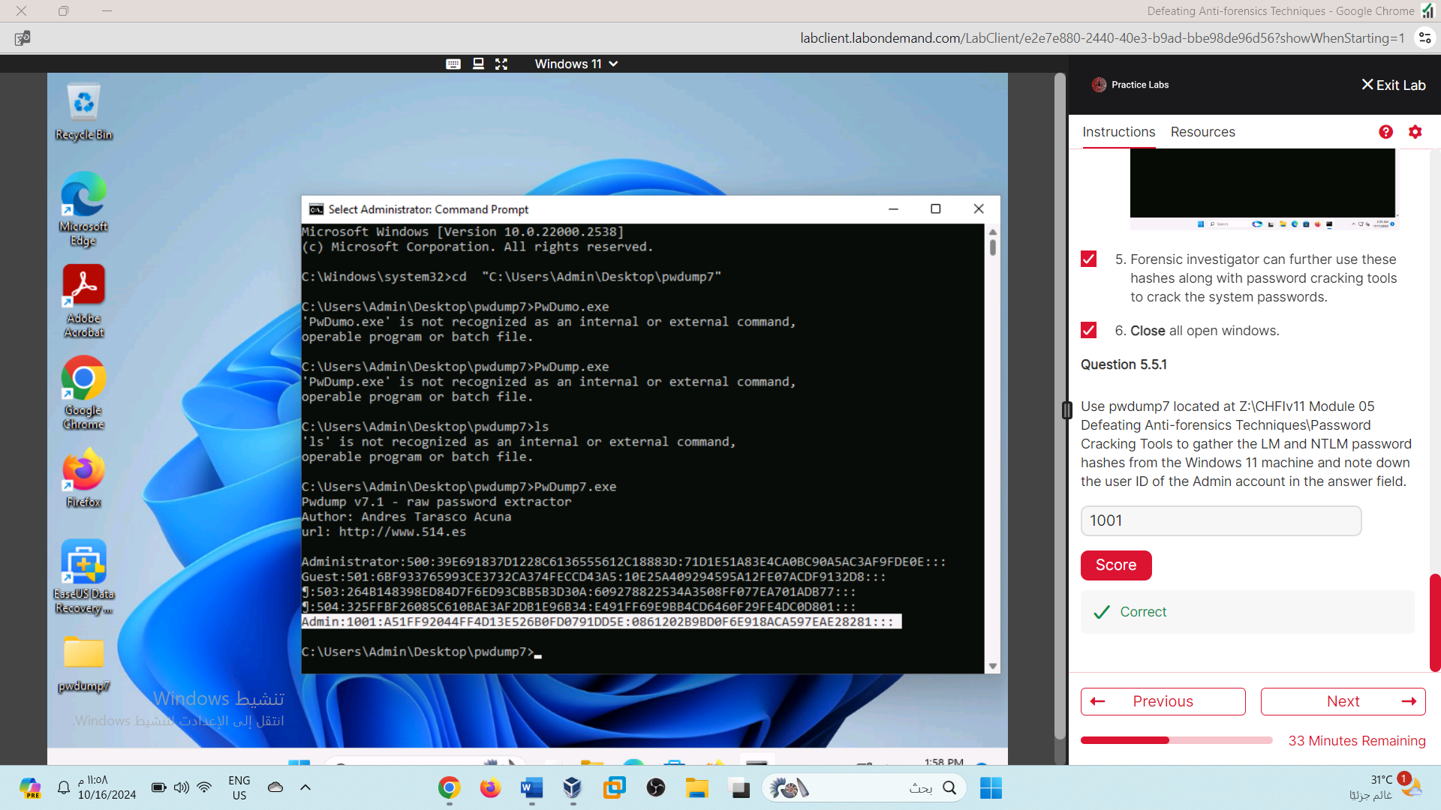

1001

Lab 06

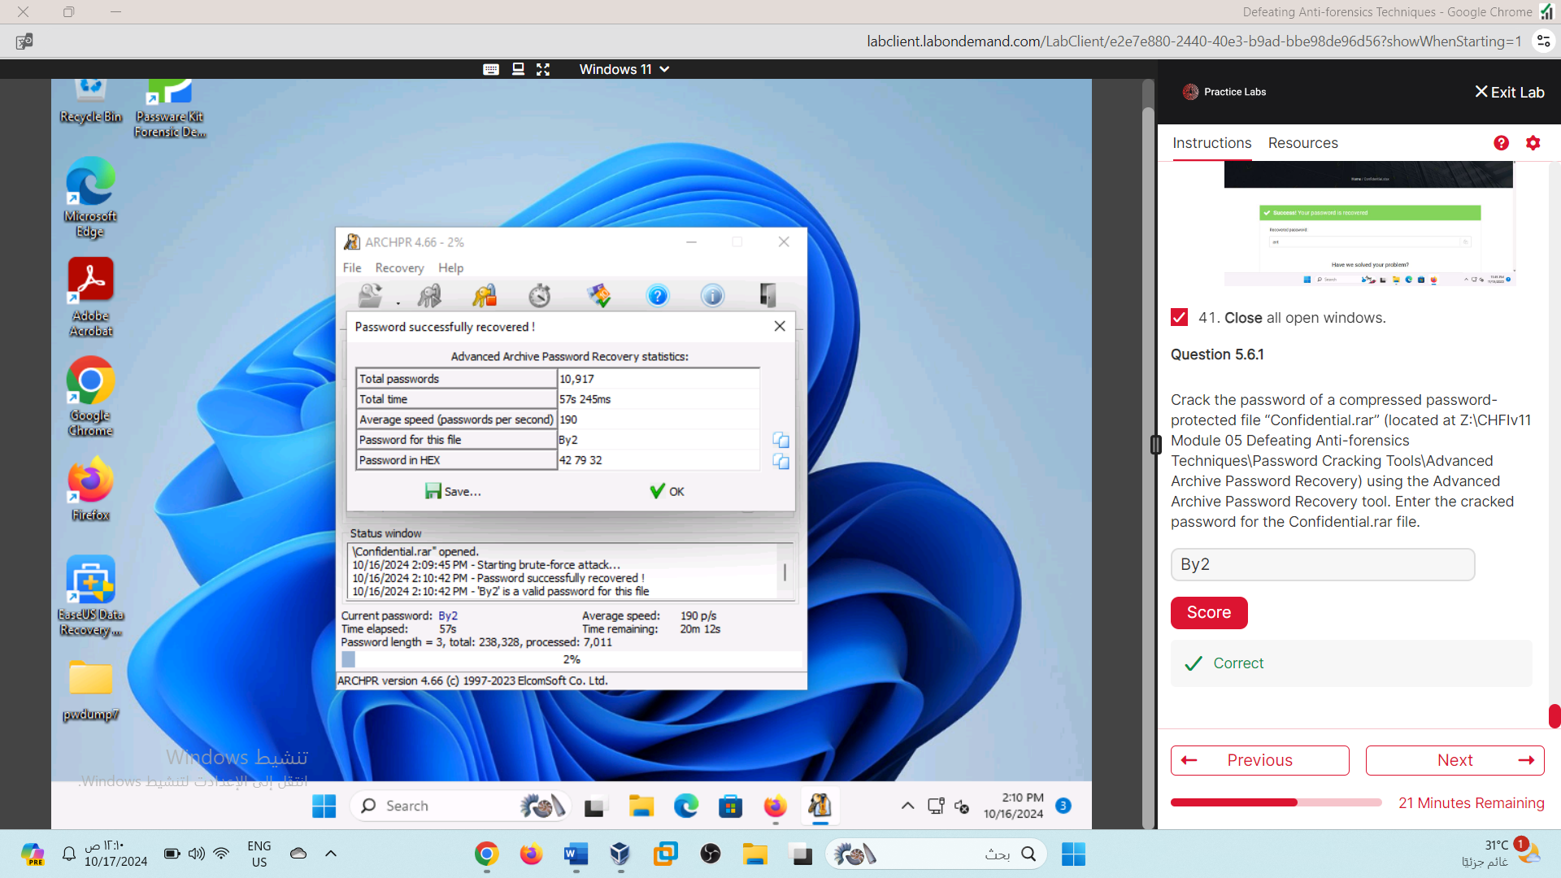

By2

Lab 07

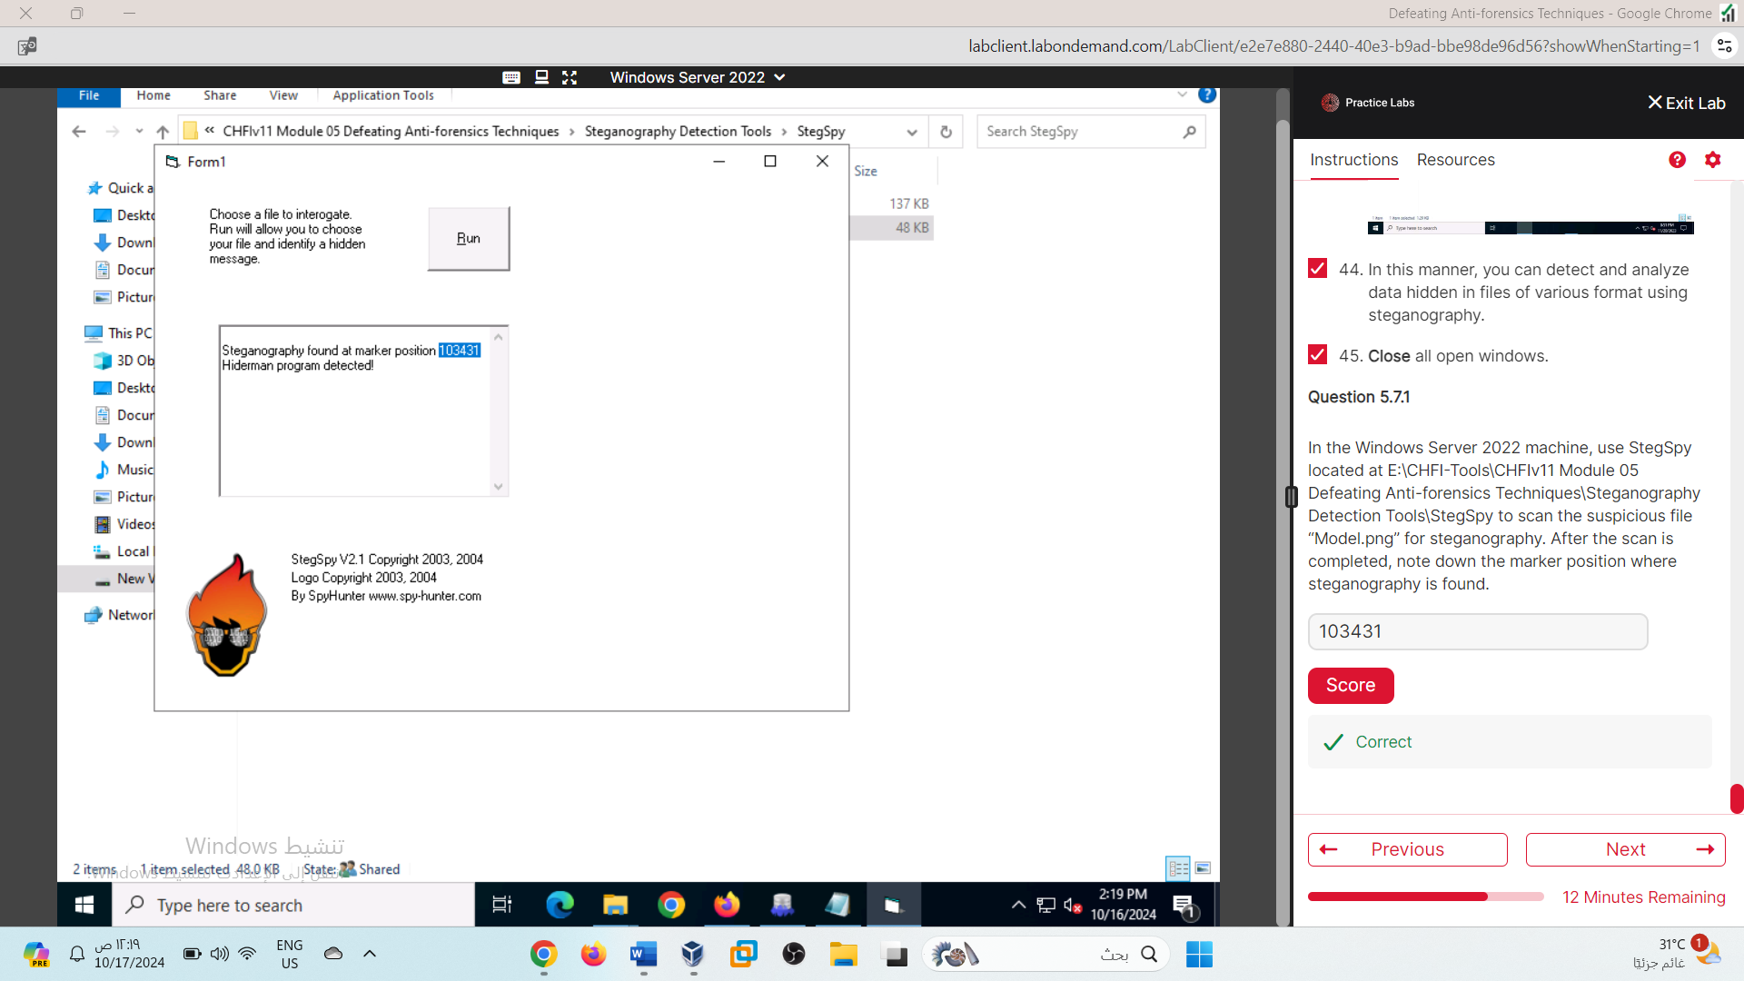

103431

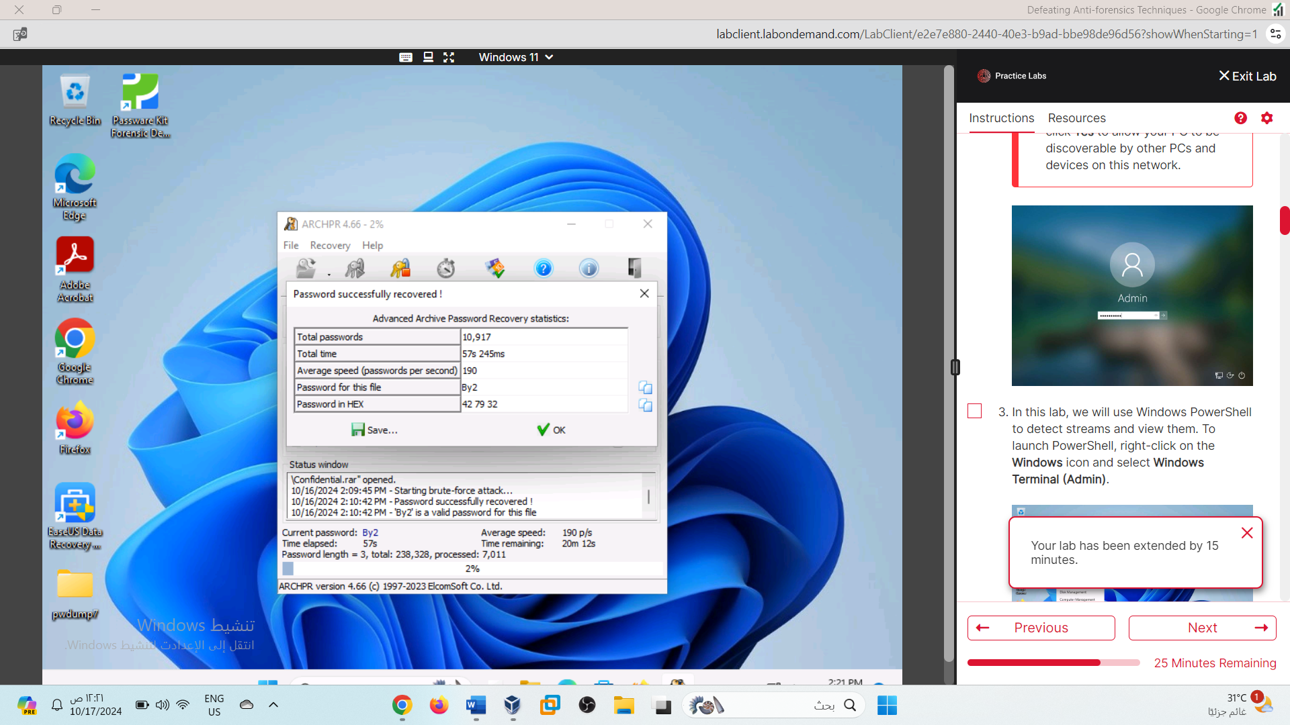

I completed the lab in another day

Lab 08

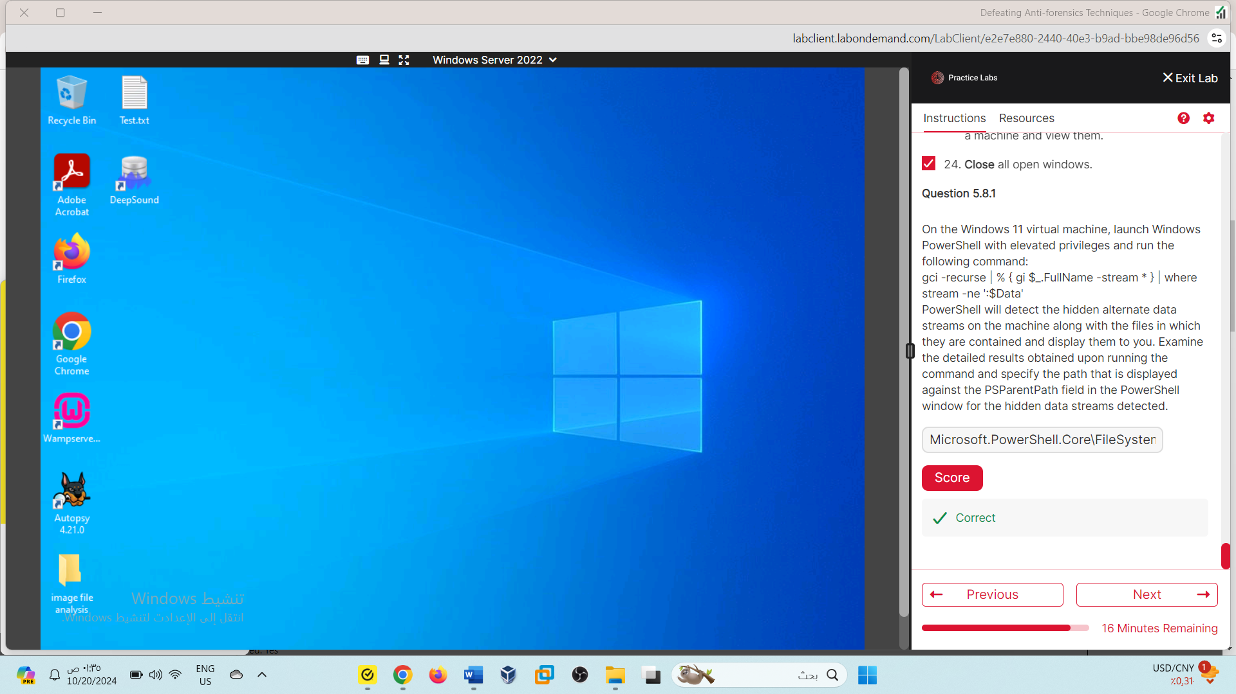

Microsoft.PowerShell.Core\FileSystem: :C:\Windows\system32

Lab 09

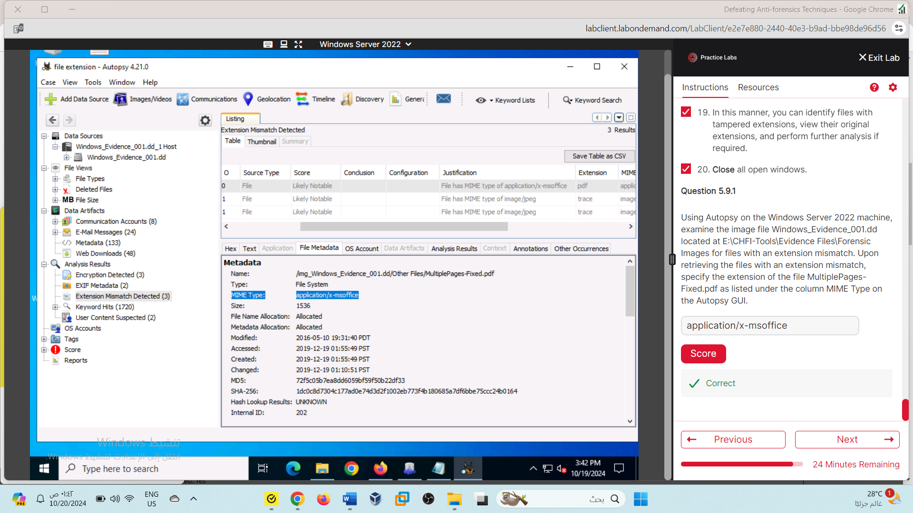

application/x-msoffice

Lab10

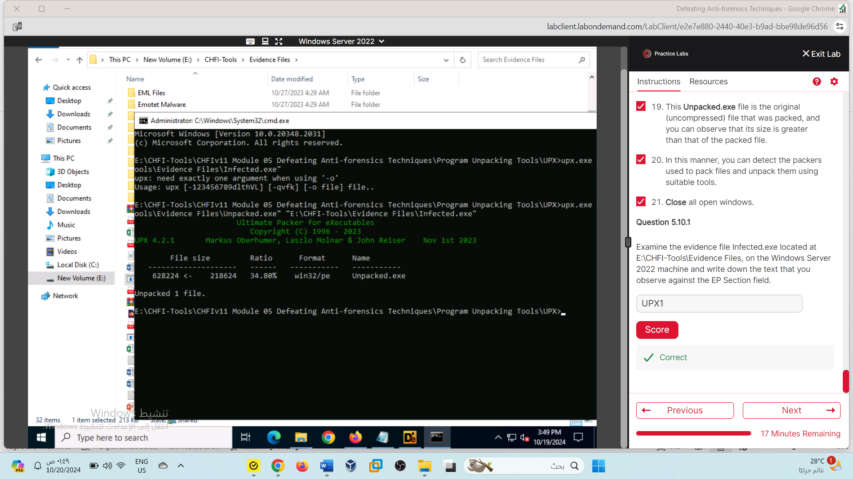

UPX1

Because of the error in Lab1, I got 9 out of 10, but I tried to submit the answer again in new session and got it right.

